GAD312 Readings & Assignments: Week 2
Week 2 Reading
Complete the following reading early in the week:
- Week 2 online lectures
- The following sections from the text, Andrew Rollings and Ernest Adams on Game Design:
  - Chapter 3: Game Settings and Worlds
  - Chapter 5: Character Development

- The Web page:
  - http://www.gamasutra.com/resource_guide/20011119/meretzky_01.htm
Note: While reading, make notes of pertinent and important facts. You will be required to reference your readings in discussions and apply them in the week's assignments.

Week 2 Assignments Overview
Assignment Summary: Week 2 | Due Date
Assignment 1: Discussion Questions | Tuesday, January 20
Assignment 2: Final Project—Defining Game World | Tuesday, January 20
Assignment 3: Final Project—Character Definition | Thursday, January 22
Assignment 4: Final Project—Concept Art for Character | Thursday, January 22
Assignment 5: Final Project—Role Assignment | Saturday, January 24
Assignment 6: Finite State Machine | Saturday, January 24
Remember that all assignment details can be found on the assignment pages located throughout the week. Go to those specific pages for direction on how to complete each individual assignment.

Week 2 Overview
Last week you learned why people play games and about different genres of videogames. You also created a High Concept document for the game that you want to design in the coming weeks. All this knowledge will provide the paraphernalia within which you'll design your game. You need more concepts and tools specific to the videogame industry.
This week, you'll learn about artificial intelligence (AI) and finite state machines (FSMs). AI is the heart and soul of videogaming and designers use it in the form of FSMs to create intelligent games. You will also study how to create the game world and you will create one for your game this week. Towards the end of Week 2, you will learn how to create appealing characters for your game.
This week may seem a little overwhelming but when you begin to implement concepts to design your own game you will discover the joy of designing a game well.

Learning Outcomes:
- Demonstrate an understanding of overall game world design.
- Design an avatar character for a 3D third-person action game.
- Be able to articulate the player's role in a hypothetical game.
- Be familiar with the idea of finite state machines.

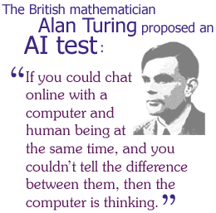
Artificial Intelligence for Game Design

What Is Artificial Intelligence?
When earlier versions of computers were constructed, computer scientists began gaining awareness about the potential of computers. They also began to wonder about the limits of computers. Computers could do arithmetic faster than human beings. How far could they go? Can a computer think? Can a computer become smarter than human beings?
These questions gave rise to a new research discipline, AI, in the field of computer science. The goal of AI is to make computers do things that normally intelligent living beings do: recognize objects by sight, make logical deductions, speak and understand human languages, walk through cluttered areas, and play games. In fact playing games was one of the earliest areas of AI research.
In the 1950s, Arthur Samuels developed a program that could play Checkers although it could not beat a human expert. Eventually checkers-playing programs became so powerful that no human could ever beat them. The best Chess programs are now unbeatable by any but a Grand Master. Commercial Chess programs have deliberately limited intelligence so that human beings have a chance against them. Chess and Checkers are fairly simple games. Other AI problems such as teaching a computer to understand English are extremely complicated. After 50 years of study we still haven't been able to build a computer that can conduct a general conversation with us.
AI mostly has been the domain of computer programmers and builders of electronic equipment. Game designers need not concern themselves with the depths of AI programming; what they need to do is to use AI to make their games responsive to the gamer.

How Games Use AI
Games use artificial intelligence:
- To provide a player with an opponent so that the player feels as if she were playing against one or more real human beings.
- To determine the actions of NPCs, characters controlled by the computer, in the game, so that their behavior seems intelligent. In most games, NPCs are hostile to the player but in some games they are friends or companions.
In the first case, the function of AI is to put up a good fight and then lose. We want to challenge the player but not so much that the player can't ever win. Commercial chess and checkers programs have difficulty levels that the player can adjust.
In the second case, AI helps the gamer's suspension of disbelief by making NPCs seem more real. Almost every genre of game uses AI in one form or another. Let's see what it does in each of the major commercial genres in descending order

AI is an essential part of game development for all genres. Let's now look beyond the concept of AI to read about some of the techniques used to add AI into games.

AI Techniques Used in Games
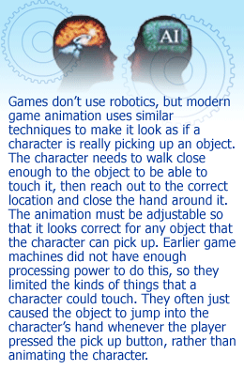
Not all areas of AI research are used in games. Some are still in their infancy and too experimental to be useful in a commercial product.
Videogames use AI techniques for:
- Game Tree Search (Looking Ahead): When you play any kind of turn-based game such as chess, you normally have a number of choices at each turn. Then your opponent makes a choice from a number of choices available. It is back to you and you have still more choices depending on what the opponent did. You can draw a graph of this showing how the options branch out at every turn. This graph is called a game tree. When you play such a game, you probably try to anticipate what your opponent will do by thinking about the choices available and then noticing what options that will leave you with. The formal name for looking ahead in this fashion is game tree search. This is exactly what programs that play simple games such as checkers actually do. AI researchers look for ways to make the game tree search more efficient.
- Pathfinding: A lot of games include units that move around autonomously through complicated landscapes with hills, forests, rivers, roads, towns, and other features. To make a simulated person or vehicle move through this landscape while avoiding all obstacles, the program must do pathfinding. The pathfinding must be intelligent enough to find routes that make sense to the player.
- Machine learning: Teaching programs to learn from experience has long been a goal of AI research. There have been some efforts to make strategy games learn by observing the player's own style but success has been mixed. These techniques are more commonly found in artificial life games in which training your creature is a big part of the gameplay.
- Computer vision: Until recently videogames didn't need to see anything because they didn't have eyes. The only pictures that they used were images that their developers had created for them. Now Sony has introduced the Eye-Toy, which takes advantage of computer vision techniques such as identifying objects and finding shapes and edges.
- Finite State Machines: This technique is most commonly used in games and is unlike most other techniques often used by the game designer. FSMs are used in games to determine the behavior of some kind of artificial being and when and why its behavior changes. This being could be anything—an animal, person, robot, or any other thing and FSM is its brain.
This is the most important AI technique from the point of view of the game designer.

Finite state machines

What Is a Finite State Machine?
As a game designer, you will work with your team's programmers to discuss the kind of behavior that you want from the game, but in most AI techniques you will have to leave it to them to implement. However there is one type of AI that you personally can help to create for a game. This is a finite state machine or FSM.
A finite state machine isn't a physical machine at all. Don't think of wheels and gears. Rather it's a conceptual machine. To create an FSM, all you need is pencil and paper (although you would need a programmer to implement the “machine” in game software).
Finite state machines are given that name because each one has a certain fixed number of possible states that it can be in. Let's take an example of a robot—a real one as it happens—to understand what is meant by these states.
In 1960, researchers at Johns Hopkins University built a small robot—Hopkins Beast. The only thing the robot did was wander around the computing laboratory. When its batteries were low, it would start to search for an electrical outlet with its photocell eye. Electrical outlets were the only objects that it could recognize. Hopkins Beast would plug itself in until its batteries were recharged. Then it would set off wandering again. Hopkins Beast had only three states: wandering, searching, and recharging. This robot was always in one state or another. That's a key quality of any FSM.
Notice that being in a fixed state doesn't mean that nothing is happening. While the robot was wandering it was moving along, keeping itself in the middle of the hallway by sonar, turning corners, and so on. It was also continually sensing the state of its battery to see if it was getting low. But at the most general level, these three things were what it did.
The states are one major part of an FSM. The other part of a FSM is the definition of how it changes from one state to another. These are called transitions. Transitions are shown by drawing thin arrows from one state to another with an explanation of what causes the change. The transition at the left that comes from nowhere indicates that wandering is the starting state.

Most FSMs in real life don't always go in a loop like this, and it is possible to have more than one condition that causes them to change from one state to another.
FSMs can have an initial state to which they never come back. One or more arrows lead out but none comes back as shown in the circle marked "S" below. They can also have one or more ending states from which they never get out. Arrows come in but none goes out, as shown in the circle marked "under attack " below. For example, if you are implementing an FSM for a soldier, one possible state is that the soldier is dead. From that state, there is no way to change to any other state.
You can create an FSM for a virtual being in your game simply by making a drawing. Any programmer who is familiar with FSMs will be able to take your drawing and convert it into software within the game.
Although it looks a little like an old-fashioned programming flowchart, an FSM is not the same thing. Unlike a flowchart, which moves on automatically when the current task is complete, an FSM stays in the same state indefinitely. It only moves on when one of the transition conditions for the current state has been met. However you can also have a default transition from short-lived states—a transition that goes out of the state immediately without any conditions being attached to it.
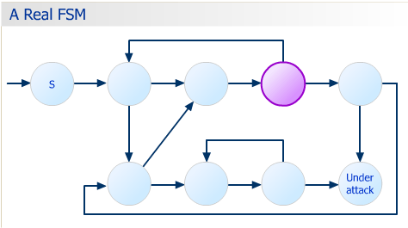
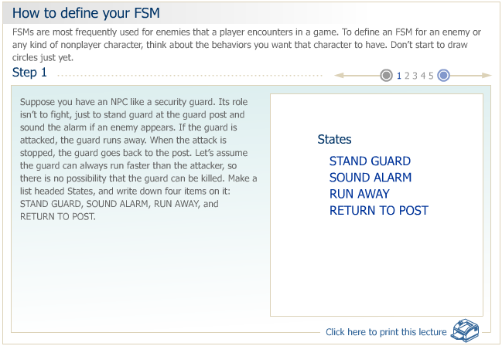
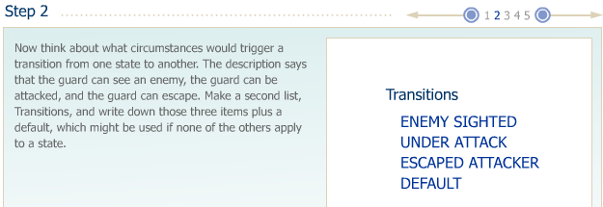
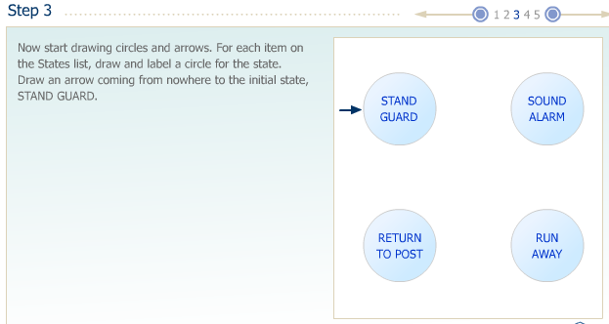
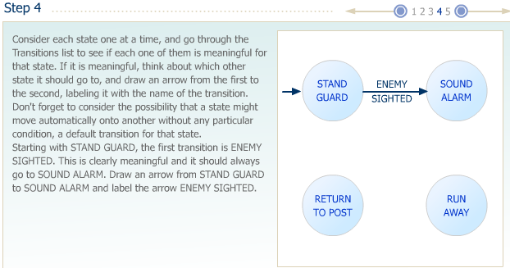
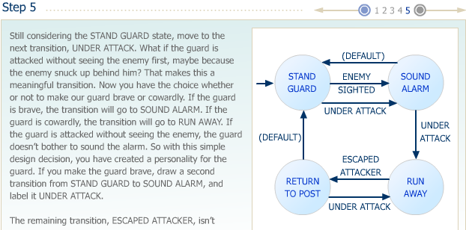
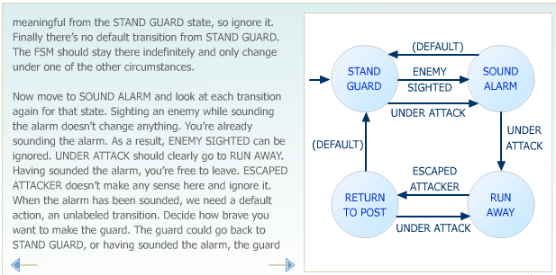
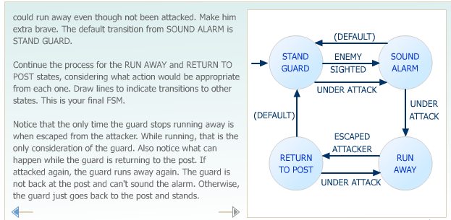
This process of building an FSM becomes unwieldy as the possible combinations of states and transitions grows larger, but works well for small games. You may find that you need to add a new state or a new transition that you didn't anticipate. Whenever you add a new transition, it's a good idea to consider it against all states to see if it's meaningful there. Whenever you add a new state, check all transitions to see if they are meaningful for that state.
As a general rule it's better not to try to make your FSM too complicated because you run the risk of introducing errors. Suppose you're creating robots that construct buildings. Instead of a single, general-purpose robot that can handle any task, it's safer and easier to create a variety of special-purpose robots each having its own FSM fine-tuned to one particular task.
Now you need to test the FSM. Let's look at how you can do that.

Testing Your FSM

The best way to test an FSM is to have a programmer build it in software and observe its behavior in a variety of test situations. Game companies have a big testing staff that works to try to break the FSM and designers and programmers can correct the FSM before it becomes part of the final product.
For this course, we'll adopt a simpler method. When you make an FSM, take the drawing and put some kind of marker such as the wide arrow in the diagrams on the initial state. Now look at every transition leading from that state and think about how it's defined. Is the definition clear and sharp? If it's not, the programmer will come and ask you what you mean and you'll have to decide. Otherwise the programmer will make something, which may or may not be what you want.
You may have noticed that the FSM you just created is a bit ambiguous. What exactly does ENEMY SIGHTED mean? Does it mean anytime that the enemy is in sight? If that's the case, our guard will switch back and forth between standing guard and sounding the alarm continuously as long as the guard can see an enemy. Does it mean the first time the guard sees a particular enemy? In that case, the guard will sound the alarm once for each new enemy who appears. Maybe it means the first and only time that the guard sees an enemy at all, in which case he will only ever sound the alarm once. As you can see it's essential to define your transitions precisely because they have a strong effect on the behavior of the NPC. In this case, it might be a good idea to redefine the ENEMY SIGHTED transition so that it means enemy visible after five or more minutes from the last alarm. That means the guard will sound the alarm at most once every five minutes.
After you've considered all transitions for a given state, move the marker to a new state and do it again until you've done them all. You have to exercise your powers of lateral thinking, trying to imagine every possible thing that could happen in your game at each state. For this to work, you need a clear mental image of the game and the sorts of situations that can arise. Because our method of construction involved trying all transitions against all states, that should take care of a lot of those situations.
FSMs are a simple but extremely powerful way of generating intelligent-seeming behavior for videogames. They're an important part of the game designer's toolkit. Build your own FSMs and test them to find their effectiveness.

Creating Your Game's World

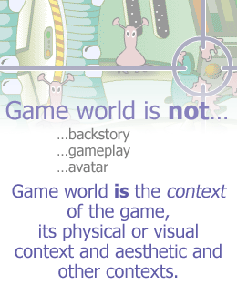
What is a Game World?
Last week, we discussed Johann Huizinga's idea of the magic circle—the dividing line between being in the game and being out of it. When you make the decision to play a game, you enter the magic circle. In a videogame, you enter the circle when you go past the setup screens and start to play the game itself. This week we'll start to talk about what's inside that circle and how to design it.
You have already created a High Concept for your game. It probably included a very brief statement, perhaps only part of one sentence about where the game takes place. For example, a game concept might sound something like:
In the role of a detective, the player will interview people and assemble clues to solve a number of crimes in New York's arts community. In each crime, the player must gather enough evidence for the prosecution to make the case.
But the concept doesn't tell us anything about what time period it takes place in, if the player is a police officer or a private detective, and so on. It's just the barest bones of the game. To create the world for that game, you need to fill in information, such as what New York's arts community means and what it looks and sounds like.
This week you'll work to fill in information about your own game concept for your Final Project. Game designers make a distinction between the game world and game setting. The setting is one part of the world, its fictional component. Almost all games require a setting and defining your game's setting is one of the larger tasks in creating the world.
But the world is more than the setting. It also helps create the player's understanding of what the game is about. Defining the game world isn't the same as defining the gameplay. The game world has a powerful influence on how it feels to be in this game even if you don't actually play it. Think about your own game concept. Imagine the player looking at your game on the screen but not actually trying to play it yet. What does the player see? What does the player hear? What is its style?
It is easier to define the game world by what it isn't than by what it is. It's not the backstory. It's not the gameplay. It's not the player's avatar. It's not the core mechanics although the game world and the core mechanics often interact with each other. The game world is the context of the game, its physical or visual context, and aesthetic and other contexts. Even something as simple as Tic-Tac-Toe has a context, the grid that you play on.
In short, the game world is an imaginary place, which can be defined in a number of dimensions: physical, temporal, environmental, and others. Some of these dimensions such as the environment are directly visible to the player. Others are not visible but are still part of the player's experience of the game world. For example, the laws of physics are an invisible part of the game world. In many racing games, cars can crash into each other without damage. In their game world, the laws of physics are distorted for gameplay purposes.
We'll discuss the concept of the game world using a sample game concept. As you read it, you should think about your own concept and what its game world is like.
Explore lock mechanisms in game design - http://www.gamedev.net/reference/articles/article1386.asp

The Physical Dimension
The first step is to define the world's physical characteristics, working from the High Concept. Our detective game is set in New York. The High Concept says that the player will interview people and assemble clues. That means moving around the city but realistically we can't model all of New York. Probably the best way to handle this is to model particular locations such as crime scenes, homes, and workplaces of the witnesses and the detective's own office. To travel between these places, establish the fiction that the detective goes everywhere by car but you don't actually see the detective drive the car. Rather the detective just automatically turns up at the front door of each location. Every time the detective learns about a new location that seems to be relevant to the case, it will be added to the list of places the detective can go.
Let's decide that the player is a police detective. This will give the detective access to police files and investigative tools such as pathology and forensic science. That means modeling the police station, morgue, forensic lab, and the district attorney's office. It would certainly be more interesting for the player to go to these places in person than it would be to communicate with them using telephone or e-mail messages.
The player is playing the role of a detective. As a result, this will be an avatar-based game. While the detective is talking to witnesses, we'll use a third-person perspective and we can see the detective as well as witnesses. This will give much more personality to the detective and increase the visual drama of situations.
- Dimensionality: This will be a three-dimensional world implemented by a 3-D rendering engine. That will enable us to go up and down stairs and wander around the locations looking for clues. You will feel as if you're really in the place. Note for later design stages: Consider a zoom-in feature that switches to first-person perspective and allows players to look at objects more closely.
- Scale: Because our movements are restricted to particular locations, there is no need to distort the scale to save space or allow the avatar to move faster. The places we visit can be at a one-to-one scale, which will make the game feel more representational of the real world.
- Boundaries: Indoor spaces will be naturally bounded by their walls. In order to limit outdoor spaces, we can bound them by fences or when necessary the tape that police use to mark off crime scenes. If the player crosses the tape, the player will automatically be asked where to go next.
- Laws of Physics: The game will not require much action or movement but when it does the laws of physics will be assumed to be the same as in the real world.

The Temporal Dimension
The temporal dimension of the game determines how time behaves. That is, the relationship between game time—the fictitious time within the game and real time—the time experienced by the player in the real world.
Time will be a meaningful element of our detective game. We want to experience New York by night and by day. Some witnesses may work a night shift and only be available then. Others will be asleep and unavailable or will refuse to answer any more questions when it is too late. Under some circumstances we may need to accomplish a task before a particular time. The passage of time will be indicated both by the detective's own watch, by clocks visible in the environment, by the sky and streetlights, and by the behavior of NPCs.
- Variable time: While we're interviewing people or examining a scene, game time will run at five times the speed of real time. As we move from place to place, quite a lot of time (minutes or hours) will pass by in a few real time seconds to represent the time spent driving. Reading case notes and examining other evidence will run faster than real time as well. Exact rates will be determined later through testing.
In order to help game time pass realistically and get through the nights when most potential witnesses are asleep, the detective will have the option of going to sleep for a while (2 to 10 hours) that the player determines. The screen will fade out to black for a few seconds and when it fades in, the detective will be back in the office and the designated amount of game time will have passed. If the detective was in the middle of an interview, the detective will have to go back to the witness to continue it. There will be no penalty for not getting enough sleep.
- Anomalous time: Anomalous time occurs when events in a game world seem to occur at different rates. For example, if it takes the same amount of real time in a game for a tree to grow to full size as it does to build a house, that's anomalous time. It is sometimes necessary to introduce anomalous time in a game design to balance the game but it's not needed in this example.
- Player-adjustable time: Sometimes it's desirable to let the player adjust the speed of time in the game world. If a game has a slow process and the player simply has to wait, you can allow the player to speed up the game clock. This is often found in flight simulators. The player wants to take off and land in real time, but to speed up time when flying straight and level for long distances. This feature isn't needed in this detective game.

The Environmental Dimension
The environmental dimension of the game world describes its appearance and sound, what the player will see and hear. These are critical parts of the player's experience and contribute the most to his sense of what it is like to be a part of this world.
The game will be set in present-day New York. The High Concept calls for its social context to be among the arts community. To offer visual variety, we'll interpret that to mean everything from the one-room apartments of poverty-stricken artists to the most exclusive galleries and museums.
- Physical surroundings: In the case of witnesses' residences, the surroundings will serve to indicate the social standing of the people who inhabit them. Wealthy people will have beautiful furnishings and immaculate houses with large rooms. Poor people will have small, decaying apartments with few possessions in them. Police facilities will look somewhat shabby and cluttered indicating a lack of funding. The inspiration for all surroundings will be New York as it really is. Art galleries will be beautiful and gleaming. Alleys will be dirty and strewn with garbage. Different locations, while fictitious, will reflect the appearance of the part of town they are in, with more or less graffiti and so on. Ambient noises will primarily be city sounds, such as traffic sounds outdoors, telephone conversations and printers in offices, quiet classical music in art galleries, echoing footsteps, and a low hum of talk in art museums, adjusted as appropriate for each location.
- Detail: To avoid overwhelming the player with possible clues, most places that the player visits will be rather spartan. Kitchens will have a reasonable number of items on the counter but drawers and cupboards will not open.
- Style: The visual style of the world itself will be that of modern New York in all its variety. The style of the depiction will be photo realistic but somewhat subdued, tending towards greys and browns. There won't be many bright sunny days. The musical style will be based on classic rock with a strong, metallic lead guitar and drumbeat.

The Emotional Dimension
Most people think of games as just being fun, but fun is too vague to be useful when we're talking about the emotional dimension of a game world. Games are a form of entertainment and part of their function is to manipulate the emotions of the player. Most games do this through gameplay. Action games do it in the simplest way by presenting the player with direct physical challenges at which the player either succeeds or fails. Strategy and role-playing games create a more mental sort of excitement through the tension of controlling units in combat. Role-playing games and construction and management simulations allow people to establish and manage something, a party of adventurers or a constructed entity of some kind. Some games entertain almost entirely by allowing the player to express creativity to build a creation of her own design.
In addition to influencing the player's emotions through gameplay, many games influence them through narrative as well. We'll study this in detail later in the course. To define the emotional dimension of your game, think about other games that you have played and how they made you feel. What events led to those feelings? Do you want to make the player feel similar things in your game?
In our detective game, the enjoyment will largely be cerebral. Players will be entertained as they put pieces of the puzzle together and satisfy their curiosity. They will experience bafflement when they don't understand what is going on and “ah-ha!” moments when they finally figure it out. They will also have the pleasure of succeeding when they obtain a conviction in the case. Other emotions they may feel include frustration if the prosecution rejects their case as inadequate. They may even feel self-criticism or guilt if the case fails because they have done something unethical (see the next page).
For further reading on this topic, see Creating Emotion in Games, by David Freeman (New Riders Publishing).

The Ethical Dimension
Every game has an ethical dimension, a moral framework that determines what actions are right and wrong in the context of the game. The rules define how the player may play and what the player must do to win. Any allowed action that leads to victory must be right. A number of recent games have been crime simulators, which require the player to commit crimes in the game context to win the game. In this case, the ethical dimension is the opposite of that in the real world and this has led to some controversy.
Although you have not yet defined the gameplay in the game, you should think through whether or not you want the game world to be moral, immoral, or amoral. In a moral game world, the player is expected to behave in ways consistent with that of the real world. Violence is justified in limited circumstances. In an immoral game world, behavior that would be unethical in the real world is actively rewarded. In an amoral game world, the game does not make value judgments. It does not distinguish between right and wrong choices as the player works to achieve victory.
In addition to the player's own actions, you should think about the moral culture of the world in which the player is playing. Is it seedy, sinister, and corrupt, or high-minded and noble? What kinds of people does the player meet?
In our detective game, we want to present the world of the New York police detective in a realistic fashion, which includes having to make some of the ethical decisions a detective must make. This includes such questions as whether or not to search a location without a warrant. How aggressively can the detective interrogate suspects? When there is probable cause for an arrest? The game will permit the player to act unethically but such actions will be discouraged in a variety of ways. Evidence may be excluded from the prosecution's case, making it more difficult to arrest the suspects and perhaps requiring more work from the player. The case may be thrown out altogether resulting in failure or the player may be censured by the police department. The practical effect of this will be that the player has less time and needs to work harder on subsequent cases. In short the moral framework will be that of the real world. There will be gray areas but in general, ethical behavior will be rewarded and unethical behavior punished.
Many suspects in a criminal investigation will be people of dubious ethics. The witnesses in our game will run the gamut from principled to distinctly shady. Some will be innocent of the crime under investigation but may try to hide information from the police for reasons of their own.
- Violence: This game is definitely not a shooter or an action game. However as it is about violent crimes it will necessarily present some violent scenes. In order to accurately model real police situations, the avatar will be armed and have the option of using the weapon on occasion. If anyone is shot, the result will be bloody but not unduly so. The depiction would be acceptable on prime time television. All the ethical standards of real world detectives will apply to the question of when and how weapons may be used. A Rambo mentality will cause the player to fail the current level.
For the most part, ethical considerations don't apply to construction and management simulations. CMSs are typically pure economic simulations without any moral framework. However you can establish undesirable conditions, which the player should try to avoid. For example, in Sim City if the player permits high levels of pollution and crime in the city, the population will leave and the player will lose income. These conditions are effectively punished by the game.
By this point, you should have a clear idea of what your game world looks like, sounds like, and feels like to be in. You won't have defined every single landscape, building, and object in your game, much of that will happen in Level Design, but you should have a general idea of what the world is like so that the artists and audio people can build it from your vision.

Creating Appealing Characters

Characters in Videogames
A character in a videogame means an active being in the game world having human-like qualities, whom the player will react to as if it were at least somewhat human. In single-player videogames, there are two kinds of characters, avatars and NPCs. The avatar is the character that represents the player, while the NPCs are all other characters in the game. NPCs are friendly or hostile and are controlled by the computer. The design considerations for an avatar are different from those for an NPC and will be addressed later in this lecture.
A character that has human-like qualities is not necessarily a humanoid. In the avatar and NPCs, there are certain characteristics, which regardless of their physical appearances help the gamer interact with these characters. So what do we mean when we say “human-like qualities”?
Normally a character in a game has some, but not necessarily all, of these characteristics:
- It can move around.
- It can talk.
- It can express emotions.
- Its behavior is not just random or automatic but seems motivated by something.
- It is a unique individual and not one of a set of identical units.
- If it is an NPC, it has some kind of attitude towards or relationship with the player's avatar.
Generally speaking, buildings, plants, and machines are not characters but there are exceptions. In a fantasy game, a talking tree might be a character. It doesn't move but it does talk to the player. In a science-fiction game, a robot could be a character even though it is a machine. It moves around and might talk or have a meaningful relationship with the player. The boundary between characters and non character entities in a game is a fuzzy one but as a designer you should maintain a consistency in your world. If you have created a highly realistic world where nothing is fantastical but suddenly a wall comes alive and begins walking towards the gamer's avatar, the suspension of disbelief will be shattered.

Visualizing Characters
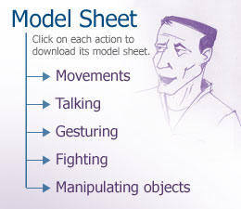
If you're an artist, it will be tempting to start making concept sketches of your characters right away. By all means go ahead and do that if it helps you think about them. For each character, draw several variations rather than trying to make one that is perfect. Try different body types, hairstyles, and clothes on your character. Your concept drawings should give the viewer a sense of what kind of a person the character is, how much money the character has, its sense of taste, where the character is from, how old the character is, and perhaps how it is likely to behave in a general sort of way. In a professional design environment, you will often want to submit a variety of options for the management to choose from.
Where do characters come from? Game designer and consultant Ernest W. Adams says:
“As a designer, I draw inspiration from characters in other games and other media such as film, TV, and television. However I don't stop there. If I rely too much on other forms of fiction, I'll just end up duplicating work that has already been done or creating trite stereotypes. So I also get ideas from people I see around me and people I read about, especially famous historical figures. People often become famous because they possess unusual qualities that make them stand out and those qualities can be used in games: think about Stephen Hawking, the brilliant physicist so crippled by ALS disease that he can barely move; or Queen Elizabeth I of England, who ruled a turbulent nation for 45 years with a combination of coquettish guile and iron will. These details make them distinctive and serve as useful models for inventing unique characters of my own.
If you think of an average man or woman, creating a character consists of adding details that make that person different from the average: taller or shorter, stronger or weaker, older or younger, and so on. A lot of these considerations are influenced by the character's role in the game, of course: you wouldn't expect a bartender to be a child. (However you can also make interesting characters by deliberately playing against type—Pippi Longstocking, the little girl who is stronger than several grown men, is an example.) One of the things that makes characters really come alive is their idiosyncrasies especially if they're charming or unexpected. Everybody remembers that Jimmy Carter was a peanut farmer because that's unusual for a president; few remember that he was also a lieutenant in the Navy. All these personal characteristics—intellect, temperament, career, and so on, tend to inform the visual look of my characters.”

Concept sketches have their limitations. A static drawing doesn't give any information about the way the character moves, the way it sounds, and the way it reacts to particular events. If you are primarily an artist, try to learn to think like an animator. In addition to your static drawings, make a model sheet for each character. Include a large variety of poses and expressions.
Animation shows us the behavior of the character in motion and over time. It tells us whether or not it struts or slouches. And if the animation includes a background and other objects, it can tell us a story about the character. Add sound and you can hear its voice. In designing a character, you should think about all these things. During this process, you might want to make a list of all possible activities you expect the character to perform. For example:
- Movements: Walking, running, jumping, lunging, crawling, climbing, sidling sideways, crouching, tumbling, rolling sideways, sneaking on tiptoe.
- Talking: Speaking, shouting, whispering, explaining (with gestures).
- Gesturing: “Look” (pointing), “Come here,” “Stop,” “Go away,” calling for help, shaking fist, waving goodbye.
- Fighting: Boxing, wrestling, firing various kinds of firearms, sword fighting.
- Manipulating objects: Picking up small, medium, and large or heavy objects off the floor, a table, or a high place, putting them down, carrying them while walking, throwing them, dropping them, handing them to another character.
If the character you're designing does something pretty simple like giving advice to the player, you can start with its visual appearance and think about other details later. For more complicated characters, especially for an avatar, you may want to think through more of the character's background and role in the game before starting to define its visual appearance.
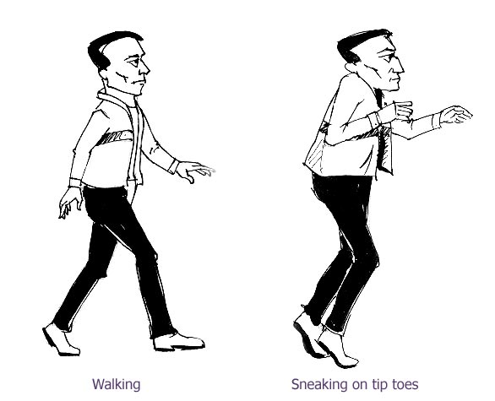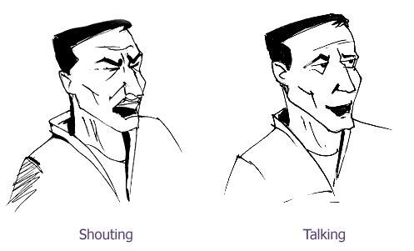
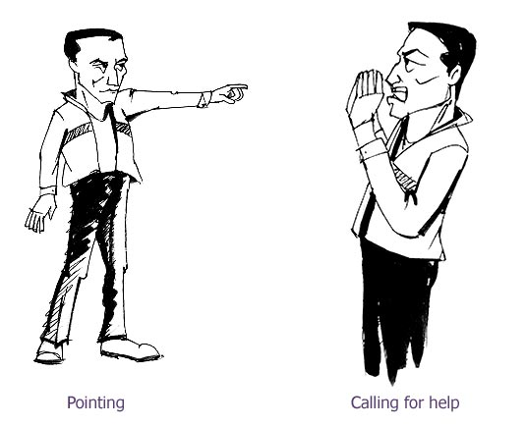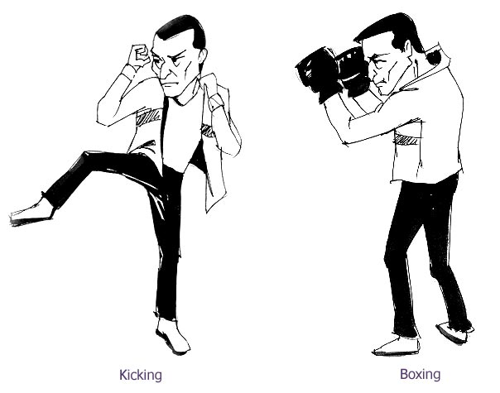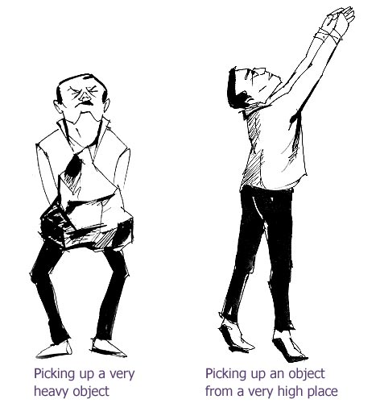

Characters and Game Genres
Most of the major genres of games use characters in some way. Let's look at how characters used in different genres differ from one another.
Role-playing games (RPGs) use many different kinds of characters—the avatar, other people in the player's adventuring party, friendly things, hostile things, neutral things, people who sell things or have information useful to the player, and so on. RPGs have more kinds of characters than any other genre of game, but their behavior is usually simple and restricted to a few key actions determined by their role such as shopkeeper, town guard, and librarian.
Adventure games typically have the richest, most detailed characters of all because much of the game is about interacting with them. Each character is completely unique and has its own goals and perspective on events in the game world. Because the characters are so complex, adventure games tend to have fewer of them than RPGs.
Action games use characters for the player's avatar and for many of its enemies. If the game uses a third-person perspective, the avatar will be visible all the time, which is vitally important. The enemies are often so mechanical that they barely qualify as characters especially if there are large numbers of them. But they all have a particular look and behavior that you must design. Bosses, extra-tough characters that the player must defeat at the end of each level definitely qualify as characters. They are usually unique, not seen elsewhere in the game, and their behavior is more complex than that of other characters.
Sports games handle every athlete as a distinct character with its own personal playing abilities. The characters in sports games frequently are modeled on real human beings, including their photographs and biographies.
Real-time strategy (RTS) games occasionally have unique hero characters or generals. However the military units in an RTS game don't normally qualify as characters because they are identical to one another and have no personality of their own. The Microsoft game Close Combat is an exception. It modeled each man in the player's platoon as a unique individual.
Puzzle games, vehicle simulators, and construction and management simulations seldom include any characters to speak of. Artificial life games include characters if the number of creatures in the game is small enough to distinguish between individuals. But if they simply seem like a large, generally identical group such as bees in a hive, you couldn't really call them characters.
The way you create a character will depend heavily on what kind of game you are designing and the role the character will play in it.

Avatars
The avatar is the player's surrogate in the game world. It is the means by which the player acts upon the world. As a result, the avatar must be someone with whom the player can identify, a character that the player can care about. This is one of the key differences between games and movies. You can make a movie about someone that you don't personally identify with but whose story is engaging. Schindler's List or Citizen Kane are good examples. But in a videogame, the player must like the avatar and want it to succeed. Most importantly, because the player will be seeing the avatar almost every minute of the game, the avatar must be someone who is appealing, someone that you enjoy watching.
The reasons why the player identifies with the character differ from game to game. An avatar walks a tightrope between being a character in its own right and having a personality and a puppet operated by the player. There are many ways to make a character appealing; it can be cute, funny, smart, resourceful, and sympathetic to others or it can be graceful, strong, attractive, mischievous, determined, and good-natured. Even a perpetual loser like Wile E. Coyote from the Roadrunner cartoons is appealing. He's clever and inventive and never gives up. Larry from the Leisure Suit Larry games is a similar sort of character—he's a loser, but a good-natured one. The Roadrunner on the other hand is almost entirely devoid of personality: apart from turning the tables on Coyote occasionally, he never does anything but run.
In first-person games, the avatar is not normally visible. Nevertheless it's useful to create a visual design for it. This helps convey its personality to others on the development team and enables you to draw pictures of it in the game world. For example, in Half-Life we don't ordinarily see Gordon Freeman during gameplay but they still designed his appearance for use in promotional materials.
Banjo and Kazooie from Banjo-Kazooie are interesting because they are two characters who together form a single avatar. Banjo is a bear and Kazooie is a bird that Banjo carries around in his backpack. This peculiar combination allows the avatar to perform both bird-like (flying) and bear-like (mauling) moves. In the original Banjo-Kazooie, they are always together but in later versions of the game they could separate and act as individual avatars.
Avatars will normally have the widest range of possible behaviors, and as a result the most animations of any character in the game. If a game has an avatar, much of the game's appeal and commercial success will depend on whether or not people like the avatar. A good avatar cannot necessarily save a bad game but a bad avatar is the kiss of death. You should expect to spend as much time on designing the look, sound, and personality of your avatar as you do on all other characters in the game put together.
Explore: Building Character - http://www.gamasutra.com/features/20000720/gard_01.htm

What Defines Non-Player Characters?
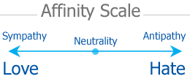
NPCs in any game can be defined by their relationships with the avatar, their functional role in the game, and their fictional role. Let's look at these three characteristics of NPCs in detail.
Relationship
NPCs run the gamut from simple action-game enemies to richly detailed people with whom the player will have many interactions. To define an NPC, identify the character's relationship to the avatar. In most cases, this will fall into one of three categories—helpful, neutral, or hostile.
Helpful characters are those who support the avatar and provide information and resources such as money and magic spells. In action games, helpful characters are often to be found only in particular locations in the game and they have a limited number of things to give the player. However a helpful character is a sidekick of the avatar and follows the avatar around through some or all of the gameplay. In most RPGs, only one member of the adventuring party is considered the avatar and other members can be considered helpful characters. Remember that when the player can control these helpful characters, they cannot be considered NPCs.
Neutral characters interact with the player but they don't provide help for free. You have to obtain something for them in exchange for their information or assistance. A character whose only function is to impede the player in a passive way, such as a doorkeeper who won't open the door until told the password, can be considered neutral. Neutral characters are most often found in RPGs and action-adventures.
Hostile characters are those who actively oppose the player's progress towards victory. They attack the avatar or do things to prevent the progress. The avatar must defeat hostile characters often through combat. Unlike neutral NPCs who are simply an obstacle, hostile characters create a risk that the player will lose the level or the game.
Sometimes you might want to create a character whose relationship with the avatar changes over time. The player's actions can cause an NPC to become more helpful or more hostile. In this case you need to define a scale of affinity and think about the kinds of events or actions that will change it. Can the avatar attack the NPC or harm it? Can the avatar assist the NPC or make friends with it in some way? How do these things happen? The answer lies in the fictional roles that you give to your NPCs and their personalities. After defining their fictional roles, you will be able to visualize how the avatar will perceive them. This will help you establish the relationship between the avatar and your NPCs.

Functional Roles
After you've decided whether the NPC is helpful, neutral, or hostile, your next task is to define its functional role within the game world. The functional role of a character implies how the character serves the gameplay, how the character influences the player's ability to overcome challenges and win the game. Functional roles include:
- Physically opposing the avatar, usually by attacking or playing as an athlete on the opposing team. This is the oldest NPC functional role going all the way back to Space Invaders and similar arcade games.
- Providing the player with advice and information. This can happen either continuously within the game as it progresses or at intervals along the way. These characters often take the form of mentors, sages, or oracles. Obi-Wan Kenobi being a classic example from the world of film. Even construction and management simulations, which normally have few characters sometimes include an advisor who makes useful suggestions and warns the player when problems crop up. This information could just as easily be supplied using a dialog box but it's good to have a character supply it.
- Giving the player quests or missions to fulfill. Many games have levels that start with a briefing of some kind often delivered by a character who plays no other role. RPGs are full of people who offer quests to the avatar and party.
- Serving as the avatar's judge or boss. Sometimes merged with the previous role, this NPC measures the player's skill and passes judgment on it from time to time, often at the end of a level.
- Trading with the avatar. These characters' function is to exchange one kind of resource for another that may help the player advance somehow. For example, blacksmiths in RPGs buy and sell armor and weapons in exchange for gold. They don't typically dispense information or assist the player in any other way.
- Being the avatar's sidekick or partner. These characters are usually weaker and less flexible than the avatar but they often perform functions that the avatar's role doesn't allow. For example, a robot sidekick might be able to explore underwater regions or rooms filled with poison gas that a human avatar couldn't enter. Barney, the security guard in Half-Life, qualifies as a sidekick of sorts. He's a better shot than Gordon Freeman, the avatar. Barney is not as tough and he can't go to places where Gordon goes.
There are many more functional roles that NPCs can serve. To explore further read The Writer's Journey: Mythic Structure for Writers, by Christopher Vogler.

Fictional Roles
The fictional role of a character determines how the player perceives the character within the game setting.
- In abstract games, the fictional roles of characters are often quite artificial. In Pac-Man, enemies appear to be colored ghosts with names, Inky, Blinky, Pinky, and Clyde.
- In representational games a character's fictional role gives it life and depth, and also helps the player to understand the character's functional role within the game. For example, in Half-Life, dangerous aliens overrun the game setting. As a security guard it makes sense that Barney would want to help the player get rid of them—a security guard is a fighter. Scientists have a different function. They can occasionally tell the player something useful, but they don't help to fight. Again their fictional role—scientists—is appropriate for their functional role as information providers.
The number of fictional roles is as endless as fiction itself. You'll have to use your imagination to decide what each NPC's fictional role is. The fictional role determines how the character talks, looks, and acts. Frequently, fictional roles of videogame characters are drawn from readily-identifiable stereotypes, the cocky young pilot, the world-weary police desk sergeant, the cheerful barmaid, and so on. You can make these less clichéd by creating a detailed character background document.
After you've created a fictional role for an NPC, you can begin to think about designing its behavior based on the role. Security guards watch, patrol, and sometimes fight, bartenders serve drinks and talk, dragons fly and rain down jets of fire. The behaviors in turn generate animations and sounds to go with them.
Well-designed characters are one of the features that make a game different from a simulation. A game isn't supposed to be a purely intellectual exercise. It entertains and involves us in a fantasy world. Characters are important to create a sense of immersion.

Building Character
By Toby Gard
Gamasutra
June 20, 2000
URL: http://www.gamasutra.com/features/20000720/gard_01.htm
As games evolve into an increasingly complex and sophisticated medium, game characters are also experiencing a considerable metamorphosis. Just a few years ago, a game character had to be simple enough so that it could be represented clearly under very severe artistic limitations. Essentially, game characters were just icons, amorphous blobs, or tiny men rendered from a handful of pixels. But steady technological progress has slowly opened up possibilities for more believable and realistic characters. The question now is, how does a game developer leverage all of these additional technical resources to create more compelling characters?
This article attempts to set out the elements of design that need to be addressed in order to create a memorable and powerful game character.
The greatest genre for characterization has always been the adventure game. Early Infogrames classics like Planetfall and LucasArts' later adventures (such as Full Throttle) showed how effective "game actors" could be, meaning characters that used spoken dialogue and were portrayed with emotional personalities. Now these game actors are moving into new cross-genre 3D games, and it is here that they really thrive. In fact, they may be becoming a little too successful; we're beginning to see games sold purely on the strength of these characters. Worse still, it seems that characters today are inserted into games that simply don't require them, perhaps because it is now seen as a marketing necessity.
The single most important rule in character design is "the game comes first." The type of game you're developing will determine most of your character-creation decisions. A character is just a tiny element of any game, and in many cases, it is a superfluous element. If a game works without a character, it shouldn't have one. The rules of elegance apply - look for the clearest, simplest way to represent an idea.
Character Identification
You can split games broadly into two groups: those with a first-person point of view (POV), and those with a third-person POV. Although that difference between them may seem slight, it is absolutely fundamental, as the psychology of the two POVs is drastically different.
A first-person game invites players to immerse themselves in the game, to play as though they themselves are in the game experiencing the events firsthand. On the other hand, the third-person game makes a distinction between the player and the on-screen character; they are separate entities. In a third-person game, the player is controlling a character rather than becoming the character.
This difference utterly splits character design into two entities that I will refer to as the "Avatar" and the "Actor." The Avatar is simply a visual representation of the player's presence within the game world. The Actor is a character distinct from the player, with its own personality, characteristics, and, to some extent, mind (Figure 1).
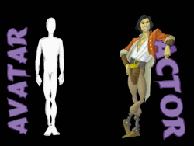
Figure 1. There is a fundamental difference between a first-person character and a third-person character.
For example, let's look at Lara Croft vs. Duke Nukem. Although some projection always occurs in games, when you play Tomb Raider, it is Lara who gets eaten by the tyrannosaurus rex and goes around shooting animals, not you. When you play Duke Nukem though, even though Duke shows a personality, it's you who gets killed and you who goes around shooting things. Many games muddy this distinction and they lose a great deal of impact on players as a result.
First-Person POV: The Avatar.
A first-person game should make it as easy as possible for players to believe that it's actually themselves in the game. The main character (the Avatar) must not interfere with the player's illusion of immersion. This means the Avatar shouldn't do anything with a mind of its own, for example it shouldn't go around talking, and the game should never take control away from the player under any circumstances. From a design point of view, the Avatar is a cipher, an empty vessel waiting to be filled and given purpose by the player.
There are two basic routes that you can go down when designing an Avatar. Either you create a deliberately insubstantial character, or better still, you allow players to create their own. This second method is even more valid when it comes to multiplayer games.
In a first-person perspective, many of the techniques of storytelling and characterization common to other mediums can't be used, simply because you don't really know what the main character, being completely controlled by the player, is going to do.
Third-Person POV: The Actor.
The third-person POV allows far greater freedom to tell what is a more traditional story form. Because the character (the Actor) on the screen is a separate entity and dissociated from the player, it's not too disturbing when the Actor acts of its own accord in certain situations. Even though this on-screen entity is controlled directly by the player, it is distinct from the player's personality, allowing the designer to imbue the Actor with a personality of its own and occasionally control how it behaves. This extra element of control over the game makes it possible to use some of the less intrusive storytelling and mood-enhancing devices that have evolved in film.
Making an Actor
From a design point of view, game characters can be sorted in order of design detail:
- Avatar. These characters require visual design only.
- Actor. Full character design, but with a necessarily one-dimensional personality so that the player can flesh out its motivations. The trick is to strike a balance between establishing the actor's personality without letting that personality disturb the player.
- Non-player characters (NPCs). These require full character design.
We all use very powerful subconscious mechanisms to judge people visually, whether we realize it or not. When you meet someone, the amount of information you gather from them using your eyes is incredible. You take into consideration their shape, height, sex, race, physical attractiveness, hair, clothing, makeup, cleanliness, facial hair, age, weight, stance, facial expressions, body language, movements, and so on. You perceive a vast amount of information almost instantly and without really trying. Your brain then begins to make assumptions about that person using built-in pattern-recognition techniques, most often based on your personal set of stereotypes. In contrast to these visual cues we pick up on, the slow linear stream of spoken information is incredibly small. After a while, our opinions may be reformed based on a person's personality, but for a long time it is still filtered through our preconceptions based on our first impressions. So to create a really good character, you have to control all of the visual clues that people use to judge each other and establish a clear, unified message to make players interested in - and ultimately like - your character.
Style and Exaggeration
In the early 1930s, Disney animators were struggling to bring the same depth of acting skills to their cartoon characters that actors were achieving in live-action films. Cartoons are a deliberately simplified representation of reality, stripped of the incredibly complex subtleties we are accustomed to in the real world. These animators realized that they could never portray the same subtleties through animation, since the medium was too broad by nature. Instead, they exaggerated all the subtle body language and emotional expressions made by actors until they became almost a pantomime of good acting. Through exaggeration, cartoons are able to elicit very powerful emotional responses from an audience, because cartoon acting is a concentrated version of live acting.
Computer games are much more akin to cartoons than films. Games aren't very good at imitating reality, because elegance requires them to be visually limited. They can't mimic the incredibly complex world we live in. If such detail could be achieved, most games would consist of overly complex, messy, and irrelevant details. Similar to cartoons, games use simplified representations of real-world ideas, stripped of the massively complicated rules found in reality. Therefore, to make the greatest impact, we have to caricature; we must amplify the aspects we want players to focus on. This is the route to making games a more powerful medium.
The Three Linked Elements
In a character-based game, there are three intrinsically linked elements: environment, game play, and character (Figure 2).
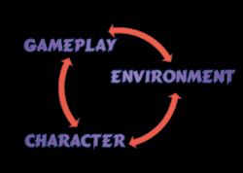
Figure 2. Much of a character's design is determined by the decisions made about a game's environment and game play.
A powerful character must be well adapted to its environment. Good characters typically have some element about them that makes them especially suited to their world. Take Indiana Jones, for example. Indiana hangs around all day in tombs and ancient sites that are filled with dangerous traps and angry natives. He is a tough, strong person, but more importantly he is an archaeologist, and this is what makes him so well suited to his environment. From a character creator's point of view, you would probably come at this in reverse: the character is an archaeologist, so therefore his environment will be tombs and ancient sites.
While the link between character and environment is true for non-interactive media as well as games, game developers must also consider an even more important factor: game play. Game play affects how an environment works. There is a link between what the player can do and what the environment contains. Game-play decisions are also dictated by a character's special abilities, so game play and character design are linked, too. Look at the character Bob in Shiny's Messiah. This little angelic character goes around and possesses people, and this attribute has massive game play significance, dictating exactly how his environment has to be populated and designed. Thus, as you change the attributes of any one of these three elements, the other two elements are affected as well.
Simply stated, the character design process cannot be isolated from the game design process. Many elements of a game character are completely decided by game play and environment.
Visual Design
The visual design of a character can be split broadly into two aspects: physiological form and the clothes worn (if any). Physiological differences between one human and another are fairly slight; there is some variation in skin tone, size, hair, build, and weight. Gender is the only major variance, and apart from that I'm afraid all humans look alike to me. Clothing, however, varies greatly in color, shape, purpose, and significance. That is why costume design is so important.
There has been a sudden surge of female main characters recently, which is good since it redresses the gender imbalance in our predominantly male industry. The choice of a character's gender is critical, and not simply from a marketing perspective. (I won't talk about any aspect of character design from a marketing point of view since I don't think it is wise to approach any aspect of design from that angle. If you design a character to be liked by players, marketing opportunities will follow of their own accord.)
A character must have dignity. Any design that objectifies the character (that is, encourages you to think of it as an object rather than a living being) will prevent players from empathizing with it and relating to it. Creating this living essence is the trick to making people like a character. Far too many female characters have been put into games simply as tokens, usually as sexy bodies for use by marketing departments. This is something to avoid.
Male and female players react to the gender of a lead character in different ways. Players usually want to protect a good character of the opposite sex, so drawing on a person's primeval and innate response to the opposite sex is a powerful tool. If the character is attractive, believable, and commands respect, players will grow fond of it. On the other hand, someone playing a good character of the same sex usually grows to admire the character and its characteristics [Can we differentiate this response better from that of opposite-sex characters?]. If the character has been designed well, the character can even develop into a role model for some players. Whatever the gender of the character, the fundamental rule for getting people to respond positively to the character is that the character must be likeable and admirable.
The Halo Effect
Some great psychology experiments have been conducted about the "halo effect," the results of which can apply to character design. Briefly, the halo effect postulates that we treat attractive people better than we do ugly people. Not only that, but we often make all sorts of subconscious assumptions based on looks. Good-looking people, according to Brigham (see References at the end of this article), are often assumed by strangers to have other positive traits such as being "poised, independent, sociable, interesting, exciting, and sexually warm." On the other hand, unattractive people are apparently seen by strangers as more "deviant," according to Jones and his colleagues.
I've heard arguments that game developers should not create a cast of highly attractive characters, either because it provides unrealistic role models for children or because some equate creating sexy characters with sexism. I don't consider it sexist to represent males and females in an equally distorted way, but action comics have been criticized for years because they portray exaggerated strength and sexiness in characters. Note, however, that as a medium comics command one of the largest groups of enduring and instantly recognizable characters.
Thus I would assert that character designers should do everything in their power to make characters as attractive as possible. A person's first impression of a character will almost certainly come not from what they do, think, or say, but what they look like. If the character makes a good first visual impression, players will likely stay focused on it, allowing you to further entice them with the character's personality.
Costume Design
Keeping a consistent costume throughout a game is the best way to help imprint the character in a person's mind, so costume changes should be avoided as much as possible until the character's visual design has become fully established. Once established, though, giving a character some costume changes will increase its believability.
Let's look at Indiana Jones again, as he appeared in films. Indiana wears his costume with some variations; sometimes without the jacket, sometimes without the hat, and in certain brief scenes he wears a completely different outfit. All in all though, Indiana keeps a strong sense of consistency which contributes to a solid, consistent image in our imagination.
The simpler a costume design is, the easier it is for a person to recognize and remember it (Figure 3). Complex, muddy, drab, and over-rendered clothing results in confusing, muddled characters. Try exaggerating essential elements of your character until you can strip it down to its essence, the simplest representation that gets across the meaning you are trying to represent.
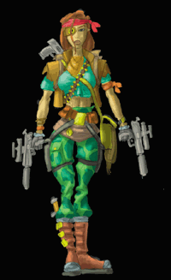 | 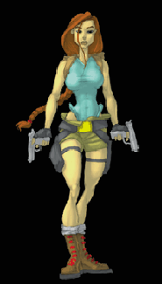
Figure 3. The character shown left has been heavily overworked. The excessive detail and overuse of colors has left it muddy and confused. In contrast, the character on the right illustrates a cleaner design.
Color schemes should be kept bold and within a limited palette. That way the colors begin to symbolize a character, just as blue, gray, and a dash of yellow invoke Batman (Figure 4)

Figure 4. Batman's color scheme is so strong that even with the added confusion of the film versions introducing black, you still can recognize him.
It's always a good idea to try to put elements into a design that help symbolize the character's essence. Obvious examples of this technique include Hermes' winged feet or the web designs on Spiderman's costume. You can also leverage the subtler associations people make about clothing and accessories to provide more clues about the character: glasses for intelligence, cardigan sweaters for massive sexual magnetism, or whatever.
Personality
Once you have a good, strikingly designed character, the next step is to work on conveying its personality. Again, the extent to which you need to portray personality depends on whether the character is an Avatar or an Actor.
I can't overstate the importance of body language when creating images of any character. Not only do people make dozens of snap assumptions based on a person's physical appearance and apparel, they also make strong judgements based on the way people carry themselves and their physical presence.
Just the way people stand reveals enough information for others to read all sorts of traits about them. The trick is to be aware of this, know what messages you want to give, and provide those cues clearly (Figure 5).
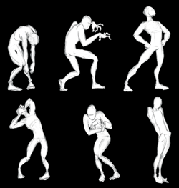
Figure 5. Even with all other visual clues stripped away, a person's pose can send very clear messages about a character.
Far too many characters are portrayed in static poses designed to look "hard." Unfortunately, the quintessential hard look is the emotionless, squinty-eyed, Charles Bronson-style stance. This does not allow people to "read" a character at all, but it works with Bronson and Clint Eastwood because that's the point of the "Man with No Name" tough guy -- he's supposed to be unreadable. So many characters imitate this look that they all fade into an obscure morass of similarity. Instead, create some attitude through poses that provide clues about the character's personality.
Poses are especially important for the static artwork typically used on game boxes and by marketing people. Dynamic poses are far more interesting, striking, and memorable than static ones. If a character is meant to be an action character, then for goodness's sake show them in motion.
Consider then taking the final step and exaggerating a character's pose to the point that it actually begins to signify the character. If you create a set of strong, distinctive poses for your character, people will recognize these poses even when seen in silhouette or from a great distance. Spiderman is an excellent example of a character that has a great array of extremely strong, immediately identifiable poses (Figure 6).
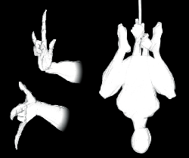
Figure 6. Spiderman's poses are so strong that you can recognize him from them alone.
Motion, The Fourth Dimension
Just as with visual design and poses, it's incredibly important to consider how a character moves, and design around that aspect.
The most important step is making a character move in a convincing way. That means showing weight, balance, and inertia. Unless you pay particular attention to the solidness that a character demonstrates while interacting with its environment, people will never accept it as anything but a group of weightless polygons. Every time a foot slides or a character snaps between animations, the illusion of life is totally shattered. Since computer game characters constantly repeat their animations, it is worth the extra time to make movement animation as flawless as possible.
Apply the concept of unique poses to the actual motion of a character. The way people walk suggests vast amounts of information about them, such as how they feel about themselves and their surroundings. If a character's movements are a consistent, exaggerated representation of their inner selves, you can build up its personality while it moves about its environment. (As a side note, there is a vast difference between realism and believability -- I feel you can always get a stronger, more universal emotional response from high-quality hand animation than you ever can from motion capture.)
Awareness
The key that Disney animators ultimately found to creating the illusion of life was showing their characters thinking. Making a character aware of its environment has an incredible impact on its believability. If your character examines its surroundings and the other characters in it, it automatically appears to be thinking about what it's looking at. Awareness doesn't just end with where a character looks, it extends to its reactions to its environment. A character can give emotional responses to what it sees, such as surprise, fear, happiness, and so on.
One aspect of awareness that reinforces a character's believability is how aware other characters are of your main character. Besides just awareness of presence, emotional responses by NPCs toward the main character add immeasurably to its substance and believability. Note, however, that the player will be affected by how NPCs react to the main character. Unless you want to lower a player's opinion of the main character, NPCs should generally react positively towards it.
What's Your Story?
I like to work out some sort of background history for a character, even if it only helps to flesh things out in my own head. Don't go too far when creating the history, though -- it's risky to give a main character loads of hidden motivations that might conflict with the player's, and the character could react in ways that make the player feel uncomfortable. At the end of the day, a game character shouldn't have anything more than superficial personality traits since, whatever the POV, the player needs to retain as much control as possible. A bit of background just helps solidify the character design process so that it can be consistent.
If a character is going to speak, the benefits of having a decent voice artist are immeasurable. We glean a host of information from each other's voices that has nothing to do with the nature or content of the words spoken. We listen to the timbre, the accent, and the range of a voice to make basic assumptions. More importantly though, we listen to the rich subtle inflections that hint at whether a person is sarcastic, sincere, intelligent, or has a sense of humor. Only highly skilled actors can evoke all of this hidden information as they deliver their lines. If anything is lacking in the voice acting, then you can't inject personality into a character even if all its other design elements are spot-on.
So much about character design is subjective. I mean, what is attractive? On that point alone you could argue for hours. But one very important thing remains to be stated. Any of the points I've discussed can, and probably should be turned on their heads if you want to create new and exciting characters. Guidelines such as these are just guidelines: ingenuity, humor, and originality require rules to be broken.
For Further Info
Thomas, Frank and Ollie Johnson. The Illusion of Life: Disney Animation. New York: Hyperion Press, 1995.
McCloud, Scott. Understanding Comics. Northampton, Mass.: Kitchen Sink Press, 1994.
References:
Brigham. "Limiting Conditions of the 'Physical Attractiveness Stereotype:' Attributions about Divorce." Journal of Research in Personality 14 (1980): 365-375.
Jones, Hannson, and Phillips. "Physical Attractiveness and Judgments of Psychotherapy." Journal of Social Psychology 105 (1978): 79-84.
Toby Gard started working in the games industry in 1994 at Core Design in Derby. While at Core, he conceived the game Tomb Raider and its main character, Lara Croft. Toby was both the designer and lead artist on the project. His roles covered everything from story development, storyboarding, FMV generation, in-game animation, character design and modeling, level flow, title and load screens, box art and marketing/PR materials. In 1997, having left Core Design, he set up Confounding Factor with business partner and lead programmer of the original Tomb Raider, Paul Douglas. Confounding Factor is currently producing the game Galleon due for release this Christmas.
Copyright © 2003 CMP Media Inc. All rights reserved.

Lock Mechanisms in Game Design
by Jonathon Schilpp
Introduction
This article focuses on a common feature of game design, which I will call a "Lock" mechanism. Although Locks may be found in many types of computer games, they are of critical importance to Adventure and Role Playing Games (RPGs.)
In order to craft a superior RPG or Adventure game, the game’s designer must do quite a lot of work. An entire world must be constructed. If the player is allowed to steer his character through this world unhindered, large sections of the game may be missed entirely.
To avoid this problem, the designer implements a Lock. This guarantees that the player will not venture further into the game world until he has more fully explored the areas he has already discovered.
How Does a Lock Work?
Here is a simple example of the Lock mechanism. Suppose that a player’s character has just entered a castle. There is a dungeon beneath the castle, which the player is eager to explore. But as a game designer, you have spent countless hours creating this castle. You have spent many late nights fashioning each NPC, and each has his own, special personality. You certainly don’t want the player to bypass all that hard work. How will the player ever appreciate your genius for game design?
In this case, you might use a Lock, something which will prevent the player from venturing into the dungeon. This may be be simple and boring, like a locked door. Or it may be something a bit more interesting, like a disgruntled castle guard who, in a fit of desperation and delerium, has barricaded himself in the dungeon’s entrance. Whatever the details, the dungeon is blocked.
In order to progress further into the game, the player must find some way of getting past the Lock. The solution which enables the player to bypass the Lock is called a Key. This may be as simple as finding a key which unlocks the door, or as complicated as solving an intricate puzzle. Whatever the details, the player cannot reach the dungeon until he has explored at least some part of the castle.
Some Common Types of Locks
All Locks have the same basic purpose. They are intended to temporarily block the player from further exploration of the game world. Locks come in many forms. A Lock may be a locked door, a ferocious beast blocking the path, a bad snowstorm which prevents travel, or anything else that a designer can imagine which will do the job.
Some Locks are so common that they deserve special mention. One common type of Lock which is a standard feature of Adventure games and RPGs is the Puzzle. There is a big difference between a puzzle which is used as an element of gameplay (such as in Tetris,) and a Puzzle which is used as part of a Lock mechanism.
Used as a Lock, the point of a Puzzle is to limit access to parts of the game world. Typically, the player encounters some obstacle, such as a path blocked by flooding, a deep chasm which cuts through a path, or something similar. In order to progress further into the game, the player must devise a solution to the Puzzle. Perhaps he must build a boat, or find something to lay across the chasm.
Switch Locks are common in Adventure games. In this case the player may encounter something like an electronic security fence. Or perhaps it is an elevated platform which is too high for the player to reach. Somewhere else, in an area the player has not yet explored, is a Switch will allow him to venture further into the game. The Switch may cut the electricity to the security fence, or it may lower the elevated platform. Of course, the Switch can be a button, computer terminal, or something else. The important point is that the obstacle is overcome by finding a release mechanism in an area some distance from the obstacle.
In RPGs, a player may encounter a Quest. This is also a Lock. In this case the player may not advance the storyline until he has performed some task. He may need to speak with a certain character, retrieve some medicine, slay a monster, rescue someone, find the Sacred Sword of the Goblin Slayers of Old, or whatever the game designer can imagine at the time.
How Are Locks Misused?
Many designers fail to use Locks properly. When Locks are poorly implemented they can have a very negative impact on the overall gaming experience. Sometimes Locks are overused in a game. Or they may be boringly similar to one another. Or they may kill the flow of the game by making the player stop and search for a Key just when suspense was building in the game. As an example of poor use of Locks, I would like to examine how they were mishandled in a game which was released a few years ago. (I will not name this game, for obvious reasons.)
This was an Adventure game, and it could have been great. The game concept was fine: an Adventure game in which players would explore a series of dungeon levels, seeking treasure and battling monsters along the way. There were a number of problems with the final product, but one of the things which doomed it right away was its horrid misuse of Locks.
All of the Locks in this game were either Switches or Doors. All of the Switches looked and functioned identically. All of the Doors looked and functioned identically. The Locks were overused, and were not implemented creatively. Even had the rest of the game been great, this misuse of Keys doomed the game to failure.
Here is the pattern which the gameplay followed, almost exactly. On any given level, the player was required to do the following: 1) Find the Silver Key, in order to 2) Unlock the Silver Door, allowing him to 3) Find the Red Key, which would enable him to 4) Unlock the Red Door, beyond which he must 5) Find the Gold Key, so that he could 6) Unlock the Gold Door and 7) Acquire yet another worthless magic sword and 8) Proceed to the next level, where the tedious proceedure would be repeated.
This unimaginative routine was already stale before the end of the first dungeon level, and grew more tiresome with every passing moment. What should have been an adventure was instead a frustrating experience. It goes without saying that the game was a dismal commercial failure.
Proper Use of Locks
The sort of design nightmare featured in the last section can easily be avoided. A game designer who cares enough to invest some time and imagination can easily master the art of using Locks effectively. In some games, like that awful Adventure, misuse of Locks can detract from the gameplay. But there are a few simple rules which will guarantee that Locks have a positive impact, leading to a better game experience.
The first rule is that the Locks must be varied. If a player encounters one or two locked doors in the course of a 50 hour game, there is no problem. But if, after the first fifteen minutes of play, the player has already encountered four of them, there is an obvious problem. On the other hand, if a player has come across one surly castle guard, a trap door in the ceiling, a backstabbing Goblin and a secret door he cannot figure out how to open, the game is much more interesting. So rule one is: Locks Should Be Varied. The designer should use his imagination as much as possible. This can be a real challenge, but the effort will be rewarded with a much better game.
The second rule deals with efficiency. If the player is required to find a Key to every Lock in the game, there will be too much time spent on finding Keys, and not enough time enjoying the game. Therefore it can be useful to use one Key which opens multiple Locks. An example of this might be when the player has the favor of the King. It is amazing how many doors this Key will open! So the second rule is: Keys Should Be Efficient. With proper planning, a game world may be devised so that a single Key may open several sections of the game world without any detrimental effect.
Sometimes a player may be required to go to considerable trouble to acquire a Key. When this is the case, being allowed to progress further into the game may not be enough of a reward. This is particularly true when the much-sought Key becomes just a worthless entry on an inventory list. "Gold Key," a player might sigh. "That’s that darn key I had to spend an hour trying to find. It’s useless now. I suppose I may as well just discard it."
But Keys do not have to become useless once they have served their purpose. A useful magic item, weapon, spell or tool can also be used as a Key. This leads to the third rule: Keys should be useful. A player is bound to have far less appreciation of an inventory item named "Key" than for one named "Fireball."
One aspect of Lock design which is often overlooked by game designers is realism. The game world is bound to have its own, unique reality. And yet, even in a game, things can be unreasonably unrealistic. Consider the way some designers use Switches. In some game worlds, Switches are everywhere: on the walls, on the floors, in the garden, on the roof, on the family’s pets..., (Well, O.K., the pets are usually safe. But nothing else seems to be!)
But is this logical? What kind of moron would design his house so that the bedroom door could only be opened by throwing switches in the kitchen and diningroom? The idea is insane! Yet many game designers expect their players to accept similar inconsistencies.
Using Locks illogically also endangers the "suspension of disbelief," one of the most important elements of game design. For these reasons, the fourth rule is: Locks and Keys Should Be Realistic.
In some game genres, most notably Horror, the mood of the game is of critical importance. Creating and maintaining a necessary mood are difficult tasks. So it is unfortunate that designers sometimes ruin the mood of their games by using Locks which are not in keeping with the mood of the game. Once lost, mood is something which is difficult to regain. So the fifth rule, which is very important in some games, is: Locks and Keys Should Be Compatible With the Mood of the Game.
And finally, the single most common misuse of Locks may be overuse. Finding a Key may not be a hassle once in a while, but too much searching for Keys can be tiresome. In some games, a player is required to search for Keys almost constantly. In these games, searching for Keys is usually used as a substitute for gameplay. In other games, the player must constantly backtrack to fetch Key items. In my opinion, these are both signs of poor game design.
I would like to point out that finding a Key should almost never entail backtracking. The Lock mechanism should be used as a tool to make the player explore areas not yet visited. Backtracking, on the other hand, forces the player to return through an already explored area. This is why fetching Keys is such a boring process in many games.
So the last rule is: Do Not Overuse Locks. There are few things which can ruin an otherwise great game so quickly as overused Locks.
A Shining Example
In an earlier section of this article, I gave an example of a game which misused Locks. I would like to balance things by providing an example of how Locks were used effectively in another game. This game I will name, if only out of respect to the hard work and skill of the game’s designers.
Castlevania: Symphony of the Night is a game which was published several years ago by Konami. In this game, the player controls the son of Dracula, and explores Dracula’s Castle. Along the way, the player learns to use his character’s vampiric abilities. What may not be readily obvious, is that these abilities were the Keys to many of the game’s Locks.
The first rule says that Locks and Keys should be varied. In this game, the Locks were things like ledges, holes in the ceiling, cliffs, and cracks in the walls. The Keys were varied as well. These included the ability to jump higher than normal, the ability to transform into a wolf, the ability to fly, etc. So the Locks and Keys were varied nicely.
The second rule says that Keys should be efficient, and that was certainly the case in this game. When the player achieved the ability to jump higher than normal, he was able to gain access to many ledges throughout the Castle. And when the player obtained the ability to fly, many more areas became available. So the Keys were very efficient.
Of course, all of these vampiric abilities were very useful to the player, which is in accordance with the third rule. (And let’s face it, transforming into a bat is just cool!)
The fourth rule says that Locks and Keys should be realistic. The locks were realistic enough: ledges, doors, crumbling walls. Of course, if my neighbor were to transform into a wolf this afternoon, I would find it unbelieveable. But in a game about vampires, this is realistic enough. And the Keys functioned realistically. It is natural to believe that a bat can fly, and therefore reach a ledge which is out of reach to a human.
And of course these Keys were in keeping with the mood of the game, as the fifth rule suggests. But more than this, the Keys in this game actually added a lot to the game experience.
The sixth rule says that Locks and Keys should not be overused. Thanks to careful, creative consideration, the designers were able to implement a great many Locks without overusing them. Because the Keys were so efficient (rule two,) and useful (rule three,) the Keys never got in the way of gameplay.
Warning Signs
Proper use of Locks is no accident. It is the direct result of careful, creative planning. And misuse of Locks is no accident either. It is the direct result of poor planning and inferior game design. At the risk of sounding pompous (which I may have been guilty of since section five,) I would like to offer some suggestions to game designers who may not have used Locks as effectively as possible in the past. Of course, every project is different, and these guidelines need to be modified accordingly.
The most common misuse of Locks are lack of variety and overuse. Lack of variety is easily addressed. If all of a game’s Locks and Keys look and function identically, the problem will be immediately obvious. A little creativity will solve this problem easily. But overuse is more difficult to judge.
I would suggest, as a general guideline, that no game should require a character to search for a key to a locked door more than twice. Even in a full-length RPG this gets boring.
Switch mechanisms are O.K., but actual, physical switches get boring very quickly. If there are more than two in any game, the designer may need to look at them carefully, and determine whether a Switch may be implemented differently.
Passwords are often used as Keys. But this should be a unique situation. I would suggest that any game which is not set in a military compound, prison, or similar setting should have no more than one password Key.
When an item is used as a Key, it is best to make it a useful item. I would suggest that no more than three Keys should become useless after opening Locks.
And lastly, I believe that with careful design backtracking can usually be avoided entirely. If backtracking is used, I think it should be limited to once or twice at most.
As I mentioned, these are only meant as guidelines, and must be modified or ignored whenever necessary.
A Final Word
The Lock mechanism can be a powerful and vital tool for game design. But like any tool, it must be used intelligently and creatively to be truly effective. In the end, I may not have said anything in this article which is not readily apparent to anyone who examines Lock mechanisms. Nevertheless, they are often misused. I hope this article will open discussion of a topic which has been largely ignored - to the gamers’ detriment.
Discuss this article in the forums
Date this article was posted to GameDev.net: 6/16/2001
(Note that this date does not necessarily correspond to the date the article was written)
See Also:
Game Mechanics
© 1999-2009 Gamedev.net. All rights reserved. Terms of Use Privacy Policy
Comments? Questions? Feedback? Click here!

Assignment 1: Discussion Questions
By Tuesday, January 20, 2009, go to the discussion area and post responses to 2 of the discussion questions assigned by the facilitator. All discussion questions should be posted to the appropriate topic in this Discussion Area.
Before the end of the week, begin commenting on at least 2 of your peers' responses. You can ask technical questions or respond generally to the overall experience. Be objective, clear, and concise. Always use constructive language, even in criticism, to work toward the goal of positive progress. Submit your responses to the appropriate topic in this Discussion Area.
Assignment 1 Grading Criteria | Maximum  Points
Response Criteria
Met the criteria for the correct responses to the questions assigned. | 3
Used vocabulary relevant to the current week's topics—at least four terms. | 3
Participation Criteria
Participated in the discussion by asking a question, providing a statement of clarification, providing a point of view with rationale, challenging a point of discussion, or making a relationship between one or more points of the discussion. | 6
Justified ideas and responses by using appropriate examples and references from texts, Web sites, and other references or personal experience. | 3
Total: | 15
For assistance with any problems you may have when completing this assignment—OR—to offer your assistance to classmates, please use the Problems and Solutions Discussion area located through the left side navigation link.
1. Choose a videogame that you are familiar with and describe its world. The game should be one in which one or more characters move around in an indoor or outdoor space. Evaluate the game on the following parameters:

- Its fictional setting and appearance
- Its visual style
- Its auditory environment
- Its emotional tone, ethics, and use of time
2. Both Mario and Lara Croft are action characters but they project distinctly different qualities. Compare and contrast them using your knowledge of character development. Who are their target markets, and what impact do the target markets have on their designs?
Assignment 2: Final Project—Defining Game World
Visualize a new game and create a High Concept document of this game for your Final Project. Define a game world for your game based on your reading assignments of this week. Explain and discuss each of the dimensions and evaluate how realistically or closely you expect it to simulate the real world laws. If you feel that it will not be highly realistic, discuss how abstract it will be by envisioning the extent to which you will have to devise abstract rules.
In addition, create concept art for the setting of the game world.
Post your Final Project file in .doc format to this Discussion Area by Tuesday, January 20, 2009.
Review and comment on the work of at least two other students early in the week.
Assignment 2 Grading Criteria | Maximum  Points
Defined the game world based on the reading assignments and included at least a few sentences about each of the physical, temporal, environmental, emotional, and ethical dimensions of the game world. | 6
Explained whether the game is realistic or abstract (or in between) with reasons. | 4
Created an image from the player's perspective of what the world, including non-interactive elements, will look like as the player plays. | 6
Illustrated the visual style of the world clearly, for example futuristic, cartoon, rich, or spartan. | 4
Posted well-formed conclusions and supported them with valid reasons. | 4
Total: | 24
For assistance with any problems you may have when completing this assignment—OR—to offer your assistance to classmates, please use the Problems and Solutions Discussion area located through the left side navigation link.

Assignment 3: Final Project–Character Definition
Write a definition of a character based on your reading assignments of this week. The character definition should include answers to questions 1–9 of the Character Development Worksheet.
Note: If your Final Project will be an action or action-adventure game, this character should be the player's avatar. If it will be an RPG, this should be one of the characters in the party. Preferably define the lead character in the RPG if it will have one. CMS and Strategy games usually don't have characters so if your game is going to be one of these then you can create any character you like.
Post your Final Project file in .doc format to this Discussion Area by Thursday, January 22, 2009. Review and comment on the work of at least two other students by the end of the week. Post your comments to this Discussion Area.
Assignment 3 Grading Criteria | Maximum  Points
Formulated a comprehensive definition of a character. | 4
Addressed the issues listed in questions 1–9. | 10
Posted well-formed conclusions and supported them with valid reasons. | 4
Total: | 18
For assistance with any problems you may have when completing this assignment—OR—to offer your assistance to classmates, please use the Problems and Solutions Discussion area located through the left side navigation link.

Assignment 4: Final Project–Concept Art for Character
After defining the world and your main character, you are ready to create concept art for the character. Draw head-to-foot front & back views and also the facial expressions for at least three different moods of your character. The concept art should also depict the main qualities that you have envisaged for your character. For example, if your character is a thief, you should give him weapons, dress, and armor that suit his profession. The gestures and expressions that you want to show in your concept art should reflect your character's profession, skills, nature etc.
Post your Final Project file in .doc format to the appropriate Discussion Area and your sketches in .jpg or .gif format to the FTP by Thursday, January 22, 2009. Review and comment on the work of at least two other students by the end of the week. Post your comments to the appropriate Discussion Area.
Assignment 4 Grading Criteria | Maximum  Points
Created a visual representation of the character. | 4
Included two (front and back) head-to-foot views of the character. | 4
Included three different facial expressions. | 6
Posted well-formed conclusions and supported them with valid reasons. | 4
Total: | 18
For assistance with any problems you may have when completing this assignment—OR—to offer your assistance to classmates, please use the Problems and Solutions Discussion area located through the left side navigation link.

Assignment 05 – Finite State Machinie – Missing

Assignment 06 – role assignment – Missing

